Computer Science II – Prepa Tec Campus Eugenio Garza Lagüera  
Activity 9: Multidimensional arrays

Name: _______________________________________________________ Student Id: ______________

**Section 1. Declare the next arrays**

* An array of integers called M1 with 100x100 dimensions.

|  |
| --- |
|  |

* An array of booleans called M2 with 1x1 dimensions.

|  |
| --- |
|  |

* A matrix M3 of 3 rows and 250 columns.

|  |
| --- |
|  |

* A square matrix (same amount of rows and columns) called M4 with 10x10 dimensions.

|  |
| --- |
|  |

**Section 2. Design a function *countZeroes* that returns how many zeroes are in a matrix. Consider that the matrix can have any dimensions and could even be a ragged array.**

For example,

|  |  |  |
| --- | --- | --- |
| 4 | 3 | 4 |
| 2 | 0 | 6 |
| 0 | 7 | 0 |

Should yield a result of 3.

|  |
| --- |
|  |

**Section 3. Do a code trace for the following problems.**

Problem 1.

x = __________

M:

|  |  |
| --- | --- |
|  |  |
|  |  |

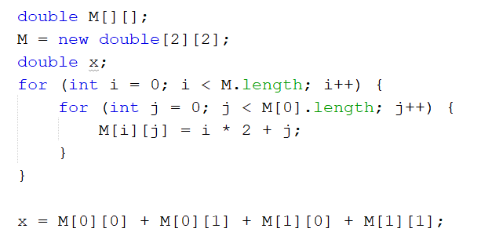

C:

|  |  |  |
| --- | --- | --- |
|  |  |  |
|  |  |  |

Problem 2.

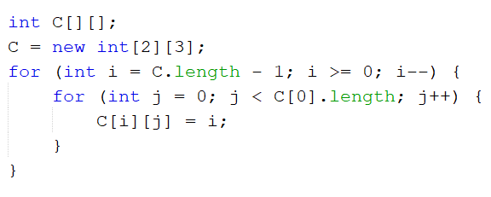

**Section 5. Pick two problems from the next list and solve them. Copy only your answers here.**

867. Transpose Matrix

<https://leetcode.com/problems/transpose-matrix/>

566. Reshape the Matrix.

<https://leetcode.com/problems/reshape-the-matrix/>

1252. Cells in Odd Values in a Matrix

<https://leetcode.com/problems/cells-with-odd-values-in-a-matrix/>